Contemplations on the Application of Water Hyacinth Cultivation as a Sustainable Economic Strategy for Agrarian Communities

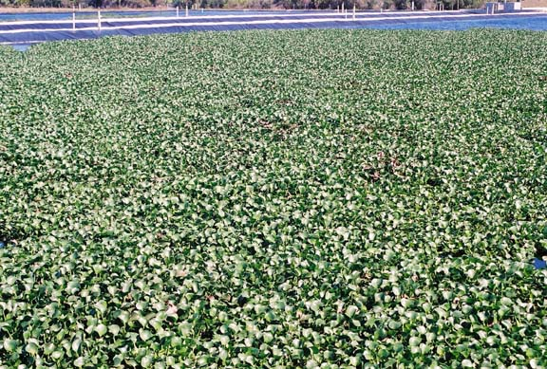

E. Allen Stewart III P.E.

2011

Chapter 1

While recent political shifts in the United States have resulted in some increased national emphasis upon critical environmental issues, including Global Climate Change, protection of water and air resources, maintenance of biodiversity, and development of non-fossil fuel energy alternatives, there remains a certain skepticism regarding the veracity and magnitude of many of these issues within much of the general public, particularly as related to the matter of Global Climate Change. In fact, it remains largely true that if one were to rely solely upon information provided by the popular U.S. press and television to form an understanding of Global Climate Change, they would believe that it was only recently that our society became aware of this issue. It can be presumed that at least in the US, many believe that the evidence suggestive of the human induced Global Climate Change remains inconclusive. In truth however, most within the world’s community of applied scientists and engineers not only acknowledged and began studying this issue well over forty years ago, they have realized for almost as long, that there would be a time when substantial efforts related to the control of greenhouse gases; serious restoration and protection of air, water, and plant and wildlife resources; and the development of practical alternatives to fossil fuels, would become essential if any semblance of stability within the global environment were to be salvaged.

What scientists can not project with certainty is the extent or timing of these impacts. Politicians, and the general public, typically not trained in the protocols of scientific investigations, often see the lack of conclusiveness from the scientific community as a sign of doubt and disagreement regarding the seriousness of Global Climate Change. Science is by nature very stingy in offering support of conclusive statements, which of course is essential in protecting objectivity. This lack of conclusiveness however has provided cause for a significant number of political leaders to remain among those skeptics more reliant upon the popular press than good science. It is not surprising therefore that at least within the United States, any serious institutional attention which has been directed to this issue has been attributable to a comparatively limited number of politicians, while among the remaining, there is noted either an ambivalence or a firmly held skepticism regarding Global Climate Change, even in the midst of solid, indicative scientific evidence.

In 1996, Warren Christopher, then Secretary of State under the Clinton Administration, at a speech at Stanford University, to the disbelief of many, announced that he believed Global Climate Change would be the most important threat to the United States in the twenty first century. The seriousness with which he offered this proclamation was somewhat surprising to a world which was enveloped in problems they saw as much more serious than Global Climate Change. Needless to say Secretary Christopher recognized how this one concern was inextricably bound, and central to these other problems, and would indeed influence the development of conflicts, environmental degradation, terrorism, economic fluctuations, energy policies, and even social and religious attitudes.

Somewhat after the Warren proclamation, Al Gore, who served as the US Vice President to Bill Clinton, stimulated awareness of the issue of Global Climate Change, through his controversial film An Inconvenient Truth and his following book, The Assault on Reason. While it was certainly the Vice President’s hope that his efforts would result in programs soliciting a world wide reduction in greenhouse gas emissions, his influence was short lived.

In the United States, Gore was criticized both for his exuberance, which was often characterized by opponents as fear mongering; and for what was claimed a bias regarding the seriousness of the Global Climate Change problem. What could be viewed as further support for this criticism emerged just before the 2009 United Nations Climate Change Conference in Copenhagen, when a series of emails were disclosed between scientists, which some say indicated efforts to identify and silence Climate Change “deniers”, and were suggestive that data was manipulated in an effort to build the case for human induced Global Climate Change. This disclosure of course compounded the criticism of Vice President Gore’s efforts, and contributed to the erosion of enthusiasm for the 2009 Copenhagen Conference. It has also thrown what began as a solely scientific exercise deeper into the tumultuous realm of politics.

With the election of Barack Obama as the US president in 2008, it appeared that the issue of Global Climate Change, as well as other critical environmental issues, would again receive serious national attention. Indeed there were initial discussions of programs such as “Cap and Trade”, and federal support for new technologies related to alternate energy programs. But by 2010 it was clear that the deterioration of the US economy would likely trump any efforts to implement meaningful programs for reducing the country’s greenhouse gas emissions. Faced with the inevitability of Senate filibusters, the president succumbed to his opposition, recognizing that any real efforts to manage issues associated with Global Climate Change would have to confront and overcome the promoted perception that such efforts would be anti-economic growth and “job-killing”.

Of course there is a paradox here, for as Global Climate Change expands its influence, human economies will be deleteriously impacted, and yet any progress towards successfully confronting the challenges associated with Global Climate Change will initially impose upon short term finances. This is the classical “grasshopper and the ant” dilemma—delays in taking action allow political avoidance of bad news in the short term, in exchange for worse news in the future.

At the core of this political dynamic is the perception of economics and economic impacts. To borrow from Hamlet—Ay, there is the rub-- for while virtually everyone will tell you they understand what economics is and what it means, most are mistaken. And they are mistaken because they would equate economics only to the movement of money, goods and wealth. In truth, economics literally means effective rule or management of one’s home—the prefix eco coming from the Greek oikos meaning home or domain, and nomics from Greek nomos, meaning rule or custom. (It is somewhat ironic, that Ecology, literally meaning study of one’s home, which many people would see as an interfering discipline to the practice of economics, has similar roots). The logical question which begs consideration is how can a person efficiently rule or manage their domain, if they have not first studied and established a working understanding of their home and the long term dynamics involved? Apparently, as evidenced by the sparse amount of time most trained economists spend studying Ecology, somewhere in the distant past someone made a conscious decision to assign the economic oikos to mean the realm of modern human society, while the Ecology oikos was assumed to mean everyone else’s home (other animals and plants and a few hunter-gatherer human groups) —as if the two were totally independent and segregated.

There are of course some recent thinkers who have challenged this particular presumption, and have suggested any segregation of the two oikoi is merely a gesture of convenience and avarice. Among these thinkers is the late H.T. Odum, who is mentioned in more detail in following chapters. Today, we may also think of economists and economic writers such as Tom Friedman, Ken Arrow and Lester Thurow as becoming more enlightened to the connection between Economics and Ecology. Paul Hawken, while not a traditionally trained economist, is recognized by many as the first entrepreneur to elaborate and act upon the relationship between an economics of sustainability and a functional, stable ecology. In his book The Ecology of Commerce, he refers to the field of Chrematistics as a convenient mimic and substitute for true economics. Chrematistics is generally thought of as the study of wealth and money, but is viewed by Hawken and others to mean the purposeful pursuit of wealth in an effort to maximize short term gains to the individual, without consideration of long term impacts.

While it has become popular today, and certainly it is a belief held by Hawken, to see modern day capitalism as being Chrematistics not economics driven, it is probably wise to avoid becoming entangled in such arguments within this limited text, as it would be an unnecessary diversion from the intent of this discourse. Rather the thoughts offered herein are not intended as invitation to prolonged esoteric arguments about game theory, or Randian, Friedman, Keynesian, or Smithian economics, which quite honestly have been argued many times before by persons much more knowledgeable, but rather as a thought inducing introduction to what is believed a workable model for sequestering and marketing atmospheric carbon, while accommodating the serious needs for nutrient and biomass energy recovery and wholesale water quality enhancement. It is further suggested that this model is truly economic in nature, meaning it finds foundation in a common oikos, and solicits efforts toward stable, sustainable social and environmental situations in which wealth is extracted, not as immediate, huge margins of short term profit, but as reliable aliquots of currency offered for contributions towards securing the stability of our global environment—our only home. It is an approach perhaps more palatable to the altruistic Angel investor, rather than what many may consider the more avaricious venture capitalist. In the United States, we would say the approach is more Jeffersonian than Hamiltonian, and accordingly, more agrarian than urban-industrial. While it is a plan whose execution would require not only some humility and patience, but also a sizable amount of thought and dedication, if implemented with cultural sensitivity, it is a plan which holds great promise for long-term service to many of the poorer countries within the developing and under-developed world; to its citizens who offer their essential labor; and of course to the investors.

Chapter 2

H.T. Odum is recognized by many as a great contributor to the understanding of our environment, and is especially appreciated by those who learned from him, and listened to him, and who studied and continue to study his writings. In 1971 he completed a book entitled Environment Power and Society which deserves reading by anyone who is trying to make sense of and find resolution to our present day environmental dilemmas— most notably Global Climate Change. Early in his book Odum makes a very important revelation:

“How many persons know that the prosperity of some modern cultures stems from the great flux of oil fuel energies pouring through machinery and not from some necessary and virtuous properties of human dedication and political designs?”

This is Odum’s rather direct announcement that we are a fossil fuel subsidized society, and it serves as a preface to the arguments that follow in his book, that disruption associated with this subsidy is so massive from an ecological perspective that major, potentially disastrous perturbations are likely, if not inevitable, and the sooner we recognize this, the sooner we can stabilize the earth’s energy dynamics such that our ability to access critical resources does not deteriorate to a dangerous level. In developing his arguments, and in the eventual formulation of what he views as necessary actions, Odum confronts the issue of money.

“Money is a special currency evolved to allow the production of one person to be rewarded by a feedback loop from some other part of society……the money value of the energy is in proportion to the work spent in receiving the energy and not in the energy itself.”

Here Odum reminds us that within a technology based human society the value of resources and items manufactured from these resources is not measured by their intrinsic energy but rather by the human effort required to bring them to market. No real value is given to the expenditure of energy through long term natural processes which resulted in the creation of resources, only to the energy expended by human society to bring the resource to market. In other words, only the human oikos is considered relevant to the “economy”. This failure to incorporate the true energy value into our economics to Odum is a critical flaw in our thoughts about “economics” which he notes as follows:

“In man’s study of himself he has often made his systems of study with the economic consideration of currency only, thus omitting much of his system. Little wonder his understanding and predictions of his economy have been faulty.”

The time is fast approaching however when Odum’s “macroscopic” view of ourselves in terms of the earth’s dynamics will dominate our economics. Warren Christopher saw it coming in 1996, just as H.T. Odum saw it in the early seventies. We are reminded through a poem by the nineteenth century English poet, William Wordsworth, that such thoughts have been with us for quite sometime, we just have not taken them that seriously until recently.

“ The world is too much with us; late and soon
Getting and spending, we lay waste our powers;
Little we see in nature that is ours.”

Chapter 3

Stimulated by recent explosions in fuel prices, and real evidence of Global Climate Change, much of the world, once again, in spite of the skeptics, has become sensitive to the issue of Global Climate Change and the need for alternatives to fossil fuels. With this invigorated sensitivity, interests and passions have grown. In recent months, information has been released expressing confidence in new methods of extracting biofuels from new and different crops; in new ways of generating cellulose based ethanol and bio-butanol; in extracting biodiesel from terrestrial crops and algae; in innovative wind and solar collectors; and in new batteries and motors and digesters and generators. In our quest for solutions, all of these ideas deserve an objective review. What is encouraging is that we are finally giving consideration to substantial commitments to direct our creative energies towards resolution of this serious problem. As with such adventures undertaken by human societies in the past, most of this creativity will shrink away in the presence of fair, unobstructed scrutiny. And while this sounds discouraging, we need to recognize that, as John Stuart Mill said, “error is an important contributor to knowledge”, and that from this deluge of ideas, objective trials and selection will ensure workable solutions evolve, and new industrial sectors emerge, built upon a paradigm of sustainability and true economics. It is the will to solve the problem that is critical, and it appears this will may be growing within the global community—even within the more recalcitrant societies, such as the United States, China, India and Australia.

One thing that is interesting when reviewing the growing collection of ideas for alternate energy and carbon sequestration, is that when solar energy is the topic, conversation is typically limited to either photovoltaic technology or direct heat exchange processes. When the perception of solar energy is restricted to these two options, we show a lack of understanding of the global importance of solar input to the dynamics of carbon cycling and energy flows. Wind, for example, is a result of solar energy, and of course Photosynthesis is driven by solar energy. Indeed, fossil fuels are nothing but stored ancient solar energy, via the process of Photosynthesis. In fact, other than human induced nuclear reactions; (recognizing that solar energy is a result of non-human induced nuclear reactions); geothermal; a portion of tidal energy assignable to the lunar gravitational influences and some contributions from chemoautotrophic reactions; the earth’s entire dynamic, (including the human dynamic), is solar energy driven. And, in terms of carbon cycling, it is Photosynthesis that typically dominates regulation of carbon from one compartment to the next.

Human induced Global Climate Change, caused largely by the release of excessive carbon dioxide into the atmosphere, is a result of an extensive and continual oxidation over the past 200 years of stored Photosynthetic-based ancient organic residuals, which we call fossil fuels. To put this in perspective, while this release has taken no more than 200 years, the initial storage of these residuals occurred over tens of millions of years. Such a dramatic temporal differential makes our use of fossil fuels somewhat analogous to breaking open a dam behind which has been stored, over an extended period, huge quantities of water. It is both obvious and unavoidable that such a rapid release will cause change—and most likely this change will be deleterious to a number of downstream life forms.

There is logic then to the thought that if stored carbon in the form of fossil fuels resulted from Photosynthesis, then why not rely again upon Photosynthesis to recapture released carbon dioxide as plant biomass. If this concept is to actually provide net carbon sequestration, Photosynthetic fixation of carbon dioxide needs to increase to a rate that approaches the rate of discharge of carbon dioxide from fossil fuel consumption. This is no small challenge, and it would require large areas which are presently providing very little production be placed into highly productive cultivation. In addition, the captured carbon in the produced biomass needs either to be used as a replacement fuel (biofuel) for an equivalent amount of fossil fuel that would otherwise have been used—meaning the biofuel can not be used for new activities—or the carbon captured within the biomass needs to be sequestered such that it will not release carbon dioxide or methane into the atmosphere.

With the biofuel scenario, the biomass would need to be converted into a usable fuel product such as biodiesel, biogas, ethanol, biobutanol, or a dried fibrous fuel. Such conversion requires energy for cultivation and production; processing; transport and distribution. Therefore it is most important that a net carbon balance be established to determine if any selected process is indeed contributory to a net reduction of atmospheric carbon dioxide.

With the carbon sequestration option, the biomass would need to be converted to a product, such as compost, which would allow stable organic molecules to be stored within the soil or large earthen basins, emulating to some extent topsoil development; a peat bog; or even coal deposits. Of course, in the production of compost, some of the more degradable organic compounds are oxidized (around 25%), meaning there can be expected no better than about a 75% capture of Photosynthetically fixed carbon within the final product. There is also a concern that in certain conditions (anaerobic, saturated environments) even the more recalcitrant carbon may eventually be converted to methane—which is an even more virulent greenhouse gas than carbon dioxide.

And there is another important issue related to the viability of highly productive crop cultivation as a method for carbon sequestration. To sustain this high production, large amounts of phosphorus and nitrogen are required, as well as potassium and calcium. These are available as inorganic fertilizers, whose manufacture requires significant expenditures of fossil fuels. If the production is land based, irrigation is also required, with associated pumping costs. And of course, ecological impacts can be significant when diverse ecosystems are replaced with highly subsidized monocultures.

To be viable then, a Photosynthetic based system for reduction of atmospheric carbon dioxide, needs to satisfy the following:

- Exploits a source of nitrogen and phosphorus (as well as potassium and calcium) which does not require additional, sizable fossil fuel expenditures in its procurement and application.

- Requires modest investments in capital and operational carbon and energy when compared to the carbon and energy returns from the process.

- Crop is sustainable, reliably productive and commercially viable.

- Does not impose upon sensitive, or highly diverse ecosystems.

- Yields a product that can either be taken to market at a reasonable cost, or can be used directly within a “village” economy to replace purchased, fossil fuel subsidized items.

- In all cases, needs to either replace fossil fuel consumption; sequester atmospheric carbon dioxide; or a combination of the two.

- Needs to be safe, and culturally and socially acceptable.

- Value will be enhanced by synergies—positive feedback, or multiple benefits.

Chapter 4

If indeed we are now being forced to confront the reality of one oikos, how do we make necessary adjustments to our economic system? One idea which has gained some popularity is to make sequestered carbon a commodity or a currency—which of course is already occurring to an extent in some regions of the world. In Europe the market price presently oscillates around $20/metric ton of carbon dioxide. James Burke in his 1990 TV series, “After the Warming” offered a sketch of an economic scheme in which developing and underdeveloped countries sell carbon credits, allocated by a global regulatory entity of some sort, to developed countries, who pay not only in cash but in technology transfer, thereby allowing the poorer countries to “leap frog” over the dirtier technologies into a cleaner infrastructure—biofuels, solar, etc. Of course, in 1990, Burke did not have a full appreciation of the economic surges that would be associated with China and India—which as developing countries are showing an initial propensity not for new cleaner technologies, but for the expediency of established, old dirty energy habits—i.e. coal and oil-- although it does appear now that China is beginning to take the development of non-fossil fuel energy seriously. Meanwhile, many undeveloped countries appear to be hardly progressing at all.

In the Kyoto Treaty we have what many see as the initial fabric of a global foundation for carbon allocation and regulation. Unfortunately, the United States chose not to ratify this Treaty in 1997. President Obama had given indications he wanted to move the country towards a stronger position of support for greenhouse gas (GHG) emission control by replacing the Kyoto Treaty with a more robust document during the Copenhagen Conference. However, the results were considered by many as disappointing, with the level of commitment assessed as weak, with the inclusions of no firm obligations for GHG reduction. The failings of the Copenhagen Conference many feel will serve only to promote the status quo.

As noted, with the election of President Obama, the seriousness of Global Climate Change has again gained national attention. However, exactly what specific steps he will be able to develop and implement, considering the chaotic state of the present political and economic conditions, are uncertain, and largely dependent upon the mood of the American people and their elected legislative representatives. Hopefully, this new administration will eventually be successful in providing meaningful incentives to the private sector to explore and develop new technologies, and to establish new economic paradigms. Historically, in the United States, freedom of creative expression has fostered miraculous developments in relatively short periods of time. Impediments to such expressions have typically been bureaucratic ineptitude, mass hysteria triggered by immediate economic challenges, and political cronyism. These can be countered and attenuated only through strong legislative and executive leadership, such as was seen in World War II; the “space race” of the sixties and seventies; and the implementation of the U.S. Clean Water Act in the seventies and early eighties.

Quite obviously, over the next decade, as a workable comprehensive plan for reducing atmospheric carbon dioxide begins to come into focus—hopefully with the full participation by the United States, Australia, China and India—there will be involved many diverse component programs and technologies. These components will include political and economic measures which support the application of not only new technologies, but also revitalized older technologies (e.g. ethanol, butanol and biogas production, nuclear power perhaps, and most notably, farming). It is hard to imagine that efforts to increase carbon dioxide uptake through Photosynthesis, supported by intensive cultivation (farming) programs, will not be central to many effective programs. Such cultivation programs most likely will often find an initial home in those countries with a sizable agrarian society; which have a relative abundance of land, nutrient pollution, water, heat, sunlight; and willing and available labor. These intensive cultivation programs would be designed to remove massive amounts of nutrients and carbon dioxide per unit area, with the carbon dioxide being sold to developing and developed countries which are under self-imposed (through either treaty or internal legislation) carbon dioxide discharge restrictions; the nutrients captured and recycled; and whose removal from the targeted surface water, results in improved water quality; and the conversion of some portion of the captured carbon to biomass energy or miscellaneous products such as compost and animal feed. Envisioned are countries in the tropical and subtropical belt of the world, particularly within desertified, low productive areas, being the most amenable to such programs. And finally, if we wish to maximize productivity, we must learn to cultivate the most productive of plants, and these would be aquatic and marine species, including vascular species as well as algae.

Such cultivation approaches have been labeled as Managed Aquatic Plant Systems or MAPS by the U.S. corporation, HydroMentia Inc. Of the crops available, the floating vascular plant the water hyacinth (Eichhornia crassipes [mort] Solms) offers several practical advantages for wholesale carbon sequestration. This proposal as presented within the next chapter is oriented around the cultivation of water hyacinths.

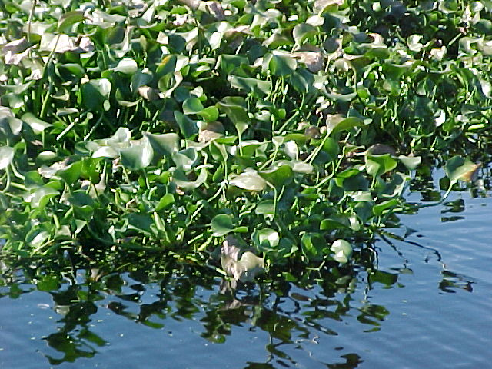

Water Hyacinths-- Eichhornia crassipes [mort] Solms-- in cultivation (Okeechobee, Florida)

Chapter 5

Much of the interest in the cultivation of water hyacinths in the United States finds genesis in the passing of the US Clean Water Act (PL-92-500) of 1972. Included in this law within Section 201, were provisions for a funded mandate related to upgrading of the nation’s wastewater treatment infra-structure. The need for this upgrading was evidenced by serious deterioration of the nation’s surface waters as a result of discharge of highly organic, highly nutritive wastewater effluents. Of particular concern was the eutrophication within critical surface waters, stimulated by the excessive nutrient loads associated with these wastewater effluents. It was in the early to mid seventies, extending into the eighties that engineers and researchers began serious review of the potential of water hyacinths to remove these excessive nutrients within southern regions of the country. Much of this early work was conducted in Florida, Texas, California, and Mississippi. Initial investigations provided indication that the water hyacinth, in the presence of a large, readily available nutrient source, was capable of very high levels of productivity and that first order kinetic models could be applied to project system design needs and performance. Based upon modeling efforts and full scale field demonstrations, a number of commercial projects were implemented in Florida during the eighties involving personnel now with HydroMentia, Inc.

For a period of about twelve years, from about 1976 to around 1988, there was considerable enthusiasm in the wastewater treatment industry, particularly in Florida and California, for the use of water hyacinths for both nutrient control and nutrient recovery. For a while, there was considerable investment made into the generation of biogas through the Gas Research Institute (GRI). Interest in pursuing this possibility appeared to wane during the mid eighties as fossil fuel prices began to stabilize downward.
There has also been a number of investigations into other uses of water hyacinths, including livestock feed, paper, compost, and specialty fiber products. A comprehensive review of work done up to 1987 was compiled by Gopal. Much of this work continues today, although typically on small scales.

It is certainly worth reviewing these and other references to gain an understanding of the concept of water hyacinth cultivation. As a warning, there is a massive amount of data available, and they do not always agree. Therefore it is somewhat difficult to discern what information is truly applicable to any given situation. The story of applied water hyacinth systems, at least within the United States, is convoluted, and is complicated by politics, economics, and conflicting disciplines. And while there are those who are still pursuing the practical application of water hyacinth cultivation, the ubiquitous enthusiasm from the earlier times has withered dramatically. In looking objectively at this history, several influences are quite recognizable, as summarized below.

- Water hyacinths were and still are viewed as an exotic weed responsible for clogging navigable waters throughout Florida and much of the tropical/subtropical world. Large industries emerged from the need to eliminate problematic water hyacinth growth in native waters. These industries, which include major Chemical companies who manufactured herbicides used to kill water hyacinths, were very powerful, and established a clandestine resistance to any effort to develop cultivation programs.

- In addition to the expansion of a quite profitable aquatic herbicide industry, universities in the US established research institutes dedicated to the control of aquatic plants, with water hyacinths central to their efforts. This resulted in the introduction of insect grazers, such as the hyacinth weevil (Neochetina eichhorniae), which proved quite effective in retarding the expansion of water hyacinth within native surface waters. These grazers of course made purposeful cultivation in the US much more challenging.

- While there was a period of time when wastewater utilities welcomed the application of cultivated water hyacinth systems, the operators and owners of these utilities never embraced the reality that this cultivation was an agricultural endeavor. Therefore they were not attentive to the need to develop specialized equipment, insect control and aggressive crop processing or marketing programs. Often the operators attempted to use available equipment items, such as draglines or track-hoes to remove the water hyacinths, which proved both expensive and inefficient.

- Conversely, agriculture showed some resistance to this new type of cultivation—i.e. wholesale, large volume floating plant aquaculture. To establish water hyacinth systems, new harvesting and management equipment needed to be developed, which could accommodate the wet conditions, and a high moisture crop, and crop uses needed to be thoroughly investigated. With the universities largely targeting the destruction of water hyacinths, they did not show a great deal of enthusiasm in investing in the development of new cultivation methods.

- While HydroMentia made the greatest strides in developing specialized equipment and developing workable harvesting strategies, as shown in the illustrations below, by reducing the energy requirements for capture and effective chopping of the harvest, the water hyacinth still remained unrecognized as a viable crop in the US, even though many realized it had value as a protein and fiber source for livestock

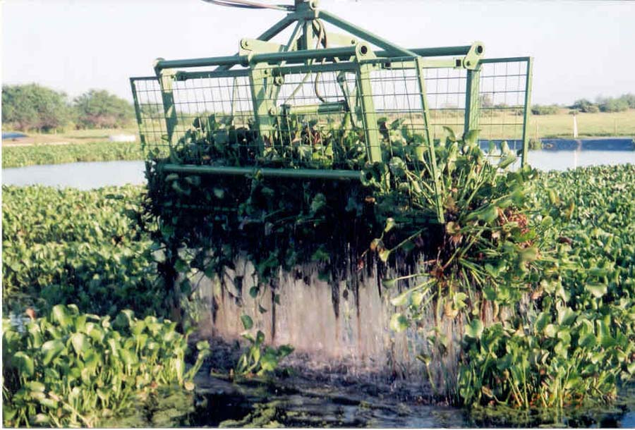

Custom designed hyacinth grapple—HydroMentia, Inc. S-154 Demonstration Project in South Florida

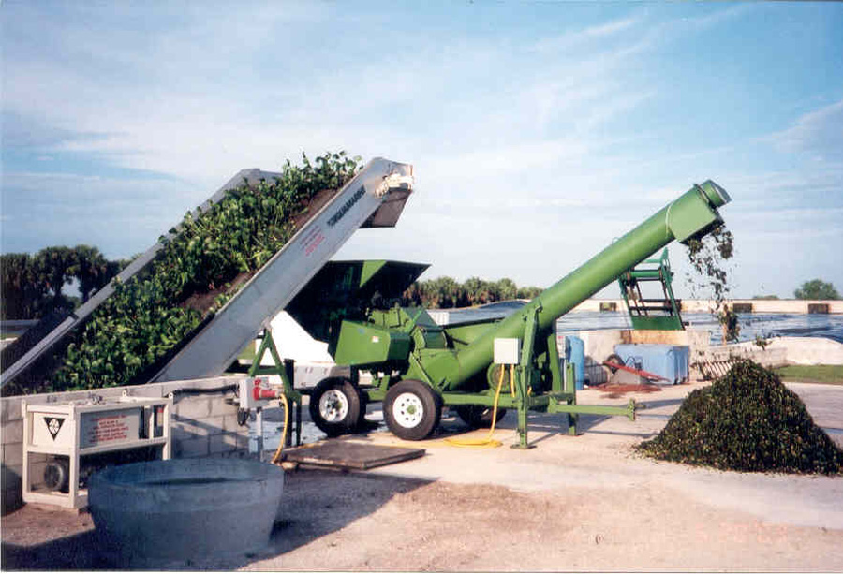

Custom designed hyacinth chopper—HydroMentia, Inc. S-154 Demonstration Project in South Florida

Custom designed hyacinth harvesting and processing arrangement—HydroMentia, Inc. S-154 Demonstration Project in South Florida

Chapter 6

When grown in water comparatively high in nutrients, water hyacinths can display a net productivity capability approaching 25 dry-g/m²-day, with a specific growth rate as high as 0.02/day and an average standing crop of nearly 1,500 dry-g/m².This amounts to about 50 kg/ha-day (44.6 lb/acre-day) of carbon, or 183 kg/ha-day (163 lb/acre-day) of carbon dioxide and about the same amounts of protein. From an energy perspective, anaerobic digestion could contribute perhaps 5-6 scf of biogas at 600 BTU/scf for each pound of volatile solids produced (about 16 dry-g/m²-day), which is equivalent to about 1.3 MBTU/ha-day. With these levels of productivity potential, it is almost inevitable that at some time in the relatively near future, water hyacinth cultivation will be developed as a major crop, with multiple marketable benefits, including the sale of sequestered carbon, or carbon offsets; water treatment; livestock feeds; organic soils and fertilizers; fiber products and renewable energy.

Considering the history of water hyacinth cultivation in the United States, and the present political and economic dynamics, it is suggested that there is not really a viable business model oriented around water hyacinth cultivation which would be easily implemented and accepted in today’s US reality. While this will likely change within the next two decades, the political environment is not friendly to such concepts at this time. Where implementation may now be feasible would be in select developing (i.e. the “BRIC” countries, except for Russia, whose climate would not be supportive), and under-developed, slowly developing countries (i.e. certain African, Central and South American, and South Asian countries). What is envisioned is a business strategy oriented around the establishment of a “cottage” industry within rural sections of the tropical/subtropical world in which the population presently suffers from a lack of access to modern conveniences, such as electrical power and efficient commodity exchanges. Perhaps more accurately, water hyacinth cultivation would be more than one of a collection of “cottage” industries, but would be the central foundation for a sustainable rural economy.

As noted previously, the selection of a viable site would be based upon land, enriched water and labor availability, as well as climate. The rural population could work communally to sustain the cultivation of water hyacinths, and would benefit equitably from their efforts through either access to products or sharing of sale of products, or both. Consider, for example, an agrarian population of about 5,000 people, substantially isolated from large cities and attendant services and utilities. Most likely this population relies upon terrestrial and livestock farming, supplemented by some fishing, hunting and gathering. Small side enterprises, such as selling illicit crops, artwork or crafts, or even eco-tourism, might allow some supplemental support. The community may well require seed and fertilizer, and pesticides, to sustain their existing agricultural activity, with sale of products suffering from the vagaries of the market, and exploitation by distributors and brokers. Energy is likely associated with wood burning, or diesel fuel used to drive generators and the few pieces of farming equipment. Community security is often provided by entities, whether government or “warlords”, which are often corrupt, and seriously drain whatever wealth which might represent a profit.

Consider now a replacement dynamic, oriented around 10,000 acres (4,050 ha) of water hyacinth ponds (about 2 acres per person). These ponds would likely be contiguous to a large water body (e.g. the Nile River), with an abundance of available nutrients. Gates would be used to replenish and release water either in a batch or continuous flow, into these ponds. Using a labor force of about 1 person per 500 acres (20 people), these ponds would yield a daily dry harvest of perhaps 1,013 metric tons, or about 203 metric tons of carbon or 744 metric tons of carbon dioxide, with a potential market value of perhaps US$14,880/day, or an annual value of US$5,413,200, or US$1,083/person. If the water hyacinth harvest were converted to a 20% protein, 30% fiber dried livestock feed, at a market value of perhaps US$200/metric ton, the annual return would be calculated at about US$74,000,000 or US$14,800/person. At first glance, it would appear livestock feed would be the best product target, but this can only be determined once expenses in production are determined. Consider also that it may be possible to sell carbon credits associated with the feed, depending upon how credits are determined.

Of course these are gross returns, and from these numbers would have to be subtracted amortized capital and land costs, energy (particularly that required for crop drying), processing, maintenance, repair and replacement, distribution, marketing, and labor support costs (health care, transport, education etc.). But even when expenses are considered, this business strategy appears to have real potential for sustainability, particularly if a major amount of the work is provided by community labor, with minimal expenditures for equipment and equipment operation. Obviously land, water and nutrient availability is critical to site selection, and to the magnitude of required initial capital. Considering a 20 year loan, at an interest rate of 4%, amortization alone would require about $55,000/ year for each $1,000,000 of capital. If the capital costs were $30,000,000, at least $1,650,000 annually would be required to meet debt loads. If 20% return on investment were desired, then an additional $330,000/yr. would be required, or a total outlay for capitalization of about $2,000,000/yr. Returns from direct sales and cost avoidance therefore would need to be substantially higher than just the carbon dioxide value.

In developing an economic strategy, consideration must be extended beyond immediate dollar returns, as the issue of sustainability is, for the long term, even more important, especially for an agrarian community. If the cultivated crop can render the community self sustaining in terms of food and energy, then it will become more or less immune to fluctuations in the global commodities market. Therefore it may be a better strategy to sell what portion of the crop to the outside market to cover capital amortization and ROI needs, as well as O&M expenditures, and turn the remainder towards optimizing sustainability. This will be particularly appropriate if certain benefits, such as carbon sequestration or water purification become add-on returns to internally used products. For example, using composted hyacinths combined with livestock manure, may reduce the community's carbon footprint by avoiding inorganic fertilization. These credits in turn could be sold. Similarly, if reduced nutrients within the targeted water body result from the hyacinth cultivation, this may result in reduced downstream needs for water treatment and aquatic plant control, which will have real cash value to urban centers which can now reduce these expenditures. These are example of positive feedback loops, as referenced earlier.

It is not difficult then to envision a multi-layered enterprise which can enhance the quality of life within an agrarian community, while rendering their social dynamic as sustainable, while also providing a decent ROI to the investors. Such a strategy could serve as a basis for establishing a complex agri-industrial economy, in which urban dynamics become dependent upon rural development and sustainability. A possible process flow as noted below is one scenario which could be applied. Certainly there are many variations to this theme, and establishing a workable blue print will depend upon a number of issues related to cultural and religious conditions, climate, land costs, available nutrient and water sources, cost of labor and energy, commodity prices, including carbon, institutional factors, interest rates, governmental stability, and a number of other more subtle issues. Development would indeed be on a case-by-case basis, and this initial cursory review should not be viewed as a final assessment, but simply as an introduction to a viable founding strategy.

Water Source

Hyacinth Cultivation Units in Series
Anaerobic Digester
Chopper
Livestock Feed
Drying Energy (supplemental to solar energy)
Feed to Market
$$$$
$$$$
Community Wastewater Treatment
Wastewater Sludge
Compost
$$$$
Water Treatment Credits

Influent Canal

Effluent Canal

Wastewater Effluent and Stormwater Run Off

Daily Harvest
$$$$

Community Energy
Sequestered CO₂

Digester Sludge
`

Community Livestock
Livestock to Market
Community Use
$$$$
Manure
Food
Crops
Crops to Market
Community Use

“Bush and Global Warming; Letting Cooler Heads Prevail” National Post, by S. Fred Singer, March 17, 2001 www.nationalpost.com
Albert Gore, 2006, An Inconvenient Truth: The Planetary Emergency of Global Warming and What We Can do About It. Rodale Books ISBN 1594865671
Albert Gore, 2007, An Assault on Reason Penguin Press ISBN 1594201226
“Inconvenient truth for Al Gore as he’s caught exaggerating the threat of Global Warming—again” Dec 16, 2009 www.dailymail.co.uk/news/article-1236090/Inconvenient-truth-Al-Gore-hes-caught-exaggerating-threat-global-warming--again.html
“Hacked e-mail is new fodder for the Climate Change Dispute” November 20, 2009 New York Times www.nytimes.com/2009/11/21/science/earth/21climate.html
“Upton’s agenda: Kill the House Climate Committee, battle “job killing” EPA October 19, 2010. http://thehill.com/blogs/e2-wire/677-e2-wire/124795-uptons-agenda-kill-the-house-climate-change-committee-battle-job-killing-epa-rules
H.T. Odum, 1924-2002, Systems Ecologist, Center for Environmental Policy, University of Florida, Gainesville, Florida.
Tom Friedman: Sept 2008 Hot, Flat and Crowded: Why we need a Green Revolution—and How it can Renew America Farrar, Straus and Giroux IBN-13:9780374166854
Kenneth Joseph Arrow, born 1921. Joan Kenney Professor of Economics and Professor of Operations Research, Emeritus at Stanford University. Nobel Prize in Economics 1972 with John Hicks.
Lester Carl Thurow, born 1938.Former dean of MIT Sloan School of Management. Presently economic columnist Boston Globe and others.
Paul Hawken, born 1946. entrepreneur, environmentalist, writer. Head of Pax Group, associated with Pax Scientific, a California based R&D corporation. Also head of Natural Capital Institute (NCI) an NGO.
Ecology of Commerce 1993. Paul Hawken HarperCollins ISBN: 0-88730-655-1
H.T. Odum, 1971,Environment, Power and Society. John Wiley and Sons ISBN 0 471 65270 9; LOC 78-129660
As a point of interest, as a young biology/chemistry student at the University of Florida in the sixties, I participated in the popular mind game of trying to unravel the symbolism associated with Tolkien’s “Lord of the Ring”. While to many it seemed obvious that the ring represented atomic energy and the threat of nuclear holocaust, a few of us suggested it represented the aromatic (benzene) ring and was symbolic of fossil fuels, whose influence needed to be returned to the hinterworld (sequestered carbon?) before the earth could regain its balance. Looking at our present situation with global climate change, we may have been on to something. Unfortunately Tolkien is no longer around to discuss this possibility with us.
The logical nutrient source would be polluted, eutrophic surface waters, of which there is no shortage in most of the world. If the nutrient pollutants associated with such waters—what are often called “rogue” nutrients-- can be extracted efficiently from these waters through cultivation of an energy crop, then the spin-off result is higher quality water. Therefore carbon sequestration and water treatment become synergistic activities—i.e. provide positive feedback. H.T. Odum realized such positive feedback loops were essential within sustainable systems.
“European Carbon Permits Fall as Slow Economy Sap Demand” May 6, 2011 Bloomberg. www.bloomberg.com/news/2011-05-06/european-carbon-permits-fall-as-slow-economy-may-sap- demand.html
James Burke, 1990. “After the Warming” PBS TV Documentary
China however has recently established aggressive programs for developing “clean” energy. “China Leading Global Race to make Clean Energy” January 30, 2011. New York Times. www.nytimes.com/2010/01/31/business/energy-environment/31renew.html
Presently, the international community is in serious debate at the UN Climate Change Conference in Durban, South Africa, trying to establish a more aggressive compliance agreement.
HydroMentia, Inc. 3233 SW 33rd Rd. Suite 201, Ocala, Florida 32744
Stewart, E. Allen, 1979.”Utilization of water hyacinths for control of nutrients in domestic wastewater, Lakeland, Florida” Aquaculture Systems for Wastewater Treatment. Seminar Proceedings and Engineering Assessment, US EPA, MCD-67, Sacramento California, p273-293
Dinges, W.R., 1976. “Who says sewage treatment plants have to be ugly? Water and Wastes Engineering. Vol 13, No. 4.
Weber, A.A. and G. Tchobanoglous. 1985. “Rational design parameters for ammonia conversion in water hyacinth treatment” J. Water Pollution Control Fed. 57:316-323
Wolverton, B.C. 1979. “Engineering design data for small vascular aquatic plant systems” Aquaculture Systems for Wastewater Treatment. Seminar Proceedings and Engineering Assessment, US EPA, MCD-67, Sacramento California, p179-191
Musil, C.F. and C.M. Breen. 1977. “The application of growth kinetics to the control of Eichhornia crassipes (mort) Solms through nutrient removal by mechanical harvesting” Hydrobiologia vol 53.2 P 165-171
Stewart, E. Allen, D.L. Haselow and N.M. Wyse. 1984. “A practical model for water hyacinth based wastewater management—design and operation. Future of Water Reuse. Proceedings: Water Reuse Symposium III. San Diego, California p679-702
Stewart, E. Allen, D.L. Haselow and N.M. Wyse. 1987. “Review and operations and performance data on five water hyacinth based treatment systems in Florida” In. Aquatic Plants for Water Treatment and Resource Recovery. K.R. Reddy and W.H. Smith. Magnolia Publishing, Inc. Altamonte Springs, Fl, USA ISBN 0-941463-00-1. p279-288
Chynoweth, D.P., D.A. Dolenc, B. Schwegler, and K.R. Reddy. 1983.Wastewater reclamation and methane production using water hyacinths and anaerobic digestion”. Proceedings 10th Energy Technology Conference, Washington, D,C,: 1-17.
Gopal, Brij. 1987. Water Hyacinth Elsevier, Amsterda ISBN 0-444-4207-6
During a full scale demonstration project combining water hyacinths cultivation with an Algal Turf Scrubber® to treat a highly enriched surface water in South Florida (“S-154 Pilot ATS™-WHS™ Aquatic Plant Treatment System Final Report 2005” Prepared for South Florida Water Management District by HydroMentia, Inc. Contract C-13933) water hyacinths were regularly harvested and chopped, with about 1,000,000 wet pounds fed to a local dairy herd as part of their greenchop program.

