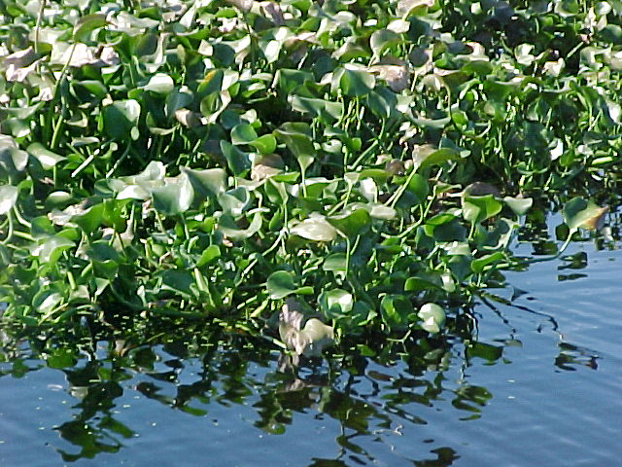

Thoughts and Discussions Regarding the Development of a New Agri-Industry based upon Cultivation of Select Aquatic Plants

September 27, 2014

Punta Gorda, Florida

PROPOSED MISSION STATEMENT

To establish a viable, sustainable and financially stable agri-industry which could be called Managed Aquatic Plant Systems or MAPS, oriented around the capture of nutrient water pollutants—what may be considered “rogue nutrients”—through the cultivation of select aquatic plant species such as the floating aquatic vascular plant, the water hyacinth, within an engineered system, and which may be supported by ancillary cultivation of select aquatic and terrestrial plants and animal husbandry. This new agri-industry would be subsidized by fees related to water reclamation services, with substantial augmentation associated with the sale of certain products and services—such as, but certainly not limited to, fiber products, fish and livestock feeds, plant protein and other food supplements, bioenergy, animal protein, pesticides, insect repellents, cosmetic additives, construction materials, pharmaceuticals, plastics compost and soil amendments, nutrient trading, and sequestration of carbon dioxide. Development and implementation of the new agri-industry could be initiated through the establishment of a full scale, privately financed, demonstration and R&D facility to be located in Florida contiguous to a large, nutrient enriched surface water body, such as Lake Apopka, which has received serious attention from State and/or Federal Agencies for reclamation, and for which fees would be available for the verified removal of the nutrients nitrogen and phosphorus. This facility would be designed around the concept of receiving fees for nutrient removal based upon a dollar value per unit weight removed ($/pound) which would be negotiated with the administering agency. These fees will help in the partial financing of serious investigation, research and development (R&D) to optimize cost effectiveness of crop selection; crop cultivation methods including system design, harvesting and initial crop handling; product processing; product values determinations and market investigations; product distribution and promotion; economic and financial evaluations; assessment of secondary benefits and liabilities; and long term stability (sustainability) through crop and product diversification.

INTRODUCTORY THOUGHTS

Cultivation of the Floating Aquatic Plant, Water Hyacinth, appears to have been initiated by the Mayan Indians probably over a thousand years ago.

*“The Mayans dredged long, parallel canals through the swamps of the area, periodically cut the water hyacinths that soon clogged the canals, and threw the vegetation between the canals. This slowly built up the level of the land between the canals to the point where it formed well-drained strips capable of producing corn, land that was regularly fertilized by new loads of water hyacinths. Meanwhile, the Mayans would net the fish that thrived in the canals. Fish and corn formed their basic diet.”[1]*

By rebuilding the soil with composted water hyacinth, the Mayans were able to replenish the thin veneer of topsoil typical of tropical forests, and hence ensure sustainability within one site. This allowed development of permanent, complex city-states, and more elaborate social dynamics.

Water hyacinth cultivation remains today as a feasible means of recovering and recycling nutrients and carbon, and therefore of contributing significantly to the establishment of a truly sustainable society. But the economic and social complexion of our culture differs substantially from the Mayans. Our economy is fossil fuel driven, while the Mayans still relied almost exclusively upon the immediate capture of solar energy through photosynthesis. It needs to be recognized that fossil fuels also represent photosynthetically captured solar energy, but as an ancient, stored solar energy. Fossil fuel is also finite, although it is so abundant that cultures and governments tend to behave as if it were inexhaustible. This has allowed us to establish a subsidized pseudo-sustainable economy oriented not around the flow of energy and materials, but rather the movement of an artificial currency we call money. Money is a deception, in that it is a *“special currency evolved to allow the production of one person to be rewarded by a feedback loop from some other part of society. [2]The money value of energy is in the proportion of work spent in receiving the energy and not in the energy itself.[3]”*

The prevalence of such a short term concept of economy, combined with a typical lack of understanding most economists have of the biological realties of the biosphere, makes it difficult to implement an effective paradigm shift towards an energy flow economic model.[4] Accordingly then, while the concept of sustainability gets a bit more lip service than it did the previous century, it is still relegated to discussions led largely by esoteric scholars and futurists[5], or political figures who do not really understand the concept.

Sustainability is generally thought of as a way to stabilize a system through recovery and reuse of crucial energies and materials. Put in another context, sustainability implies a quasi-steady state dynamic, where inputs equal outputs and the rate of change approaches zero. This is a system in which entropy is a minimum and survivability is temporally extended[6]. Consumption of finite resources is not sustainable, nor does a system depending upon such consumption have any degree of survivability[7]. We can think of the present day social *modus operandi* like the character in the cartoon below—enjoying a pleasant ride towards some impending catastrophe.



How’s it Going?



So far, so good!

But these issues related to consumption and stability do not receive much serious attention today—although they probably will within the next fifty years. Consequently it is not reasonable to think a company could be successful relying solely upon the promotion of sustainability, although this might enhance market appeal. What is needed is a company that indeed embraces the practice of sustainability, but in addition provides products and services that have real marketability. What we need to ask ourselves then is:

*Can we establish a new agri-industry business that provides valuable products and services to real, identifiable markets , such that the collective pecuniary returns from the sale of such products and services exceeds all fixed and continuing costs?*

CHALLENGES

Each of us here likely believe that there is some combination of cultivation, collecting, processing and marketing that would establish MAPS facilities as not only economic viable, but as a substantial industry that provides new materials, services and job opportunities that contribute to economic efficiency. Note I did not say economic growth—rather economic efficiency. There is a difference between growth and efficiency. Growth is gaining fifty pounds and impairing your health. Efficiency is finding that weight where you can optimize your mobility and maintain good health. It goes back to sustainability—but this is a discussion for another day.

When one considers how productive aquatic plants (e.g. water hyacinth) are, it would seem that their cultivation would be easy. I have been involved in such cultivation for almost forty years—trust me it is more difficult and demanding than you might think. First of all, to maintain high productivity, sufficient nutrients and minerals must be available, and as important, harvesting must be frequent enough to maintain a healthy crop and to optimize production. To get a general idea of relative productivity, we have cultivated hyacinths which have yielded with biweekly harvest from a standing crop of 9,800 dry pound/acre, about 36,000 dry pounds per acre each year, with about 7,200 pounds of this as protein, and perhaps 10,000 pounds as fiber. By comparison, wheat may produce 6,000 dry pounds per year, with perhaps 900 pounds as protein. At first glance this seems extraordinary—and it is. But this production demands weekly to biweekly harvesting of a crop that is 95% water. This means a harvest of about 360 wet tons per year for each acre. Equipment and methods just for removal must be designed to do this efficiently, otherwise costs for just removing the biomass from a cultivation pond would be substantial. Once the crop is removed it needs to be transported and processed. Transporting something of which only 5% is recoverable—the rest being water—must be efficient, and the distance short. After transporting, then the product needs to be processed. This is not an easy task, considering the crop is wet and fibrous. Chopping to reduce volume can be done if it is compatible with your target product—such as compost or livestock feed.

In the pictures below are shown equipment and methods we developed and have found effective for harvesting, transporting and chopping when the end product was compost and greenchop for dairy cattle. The pick-up head is a light weight grapple on a tractor PTO. The pick-up height is eight feet and the horizontal transport is about 20 feet. The hyacinths are dropped into a canal with water moving the plants to a pick-up conveyor, which lifts another 15 feet, then drops it into an electric motor driven modified corn chopper, which reduces the volume by about 20 times, with average particle size about ¼ square inch. The system can harvest about 10-20 wet tons per hour with 1-2 men. The operational costs alone of this system may approach $90/dry-ton, or $450/ton of protein[8]. Each dry ton would contain about 7 pounds of phosphorus, for which under a reasonable water pollution control service contract may yield a return of $210. I will not go through a detailed financial review, but this clearly indicates that the system benefits from a water pollution control fee.

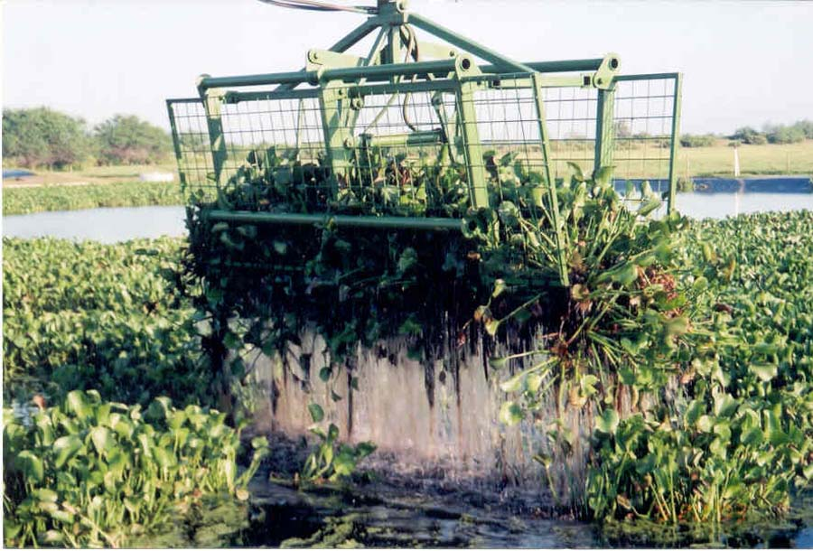



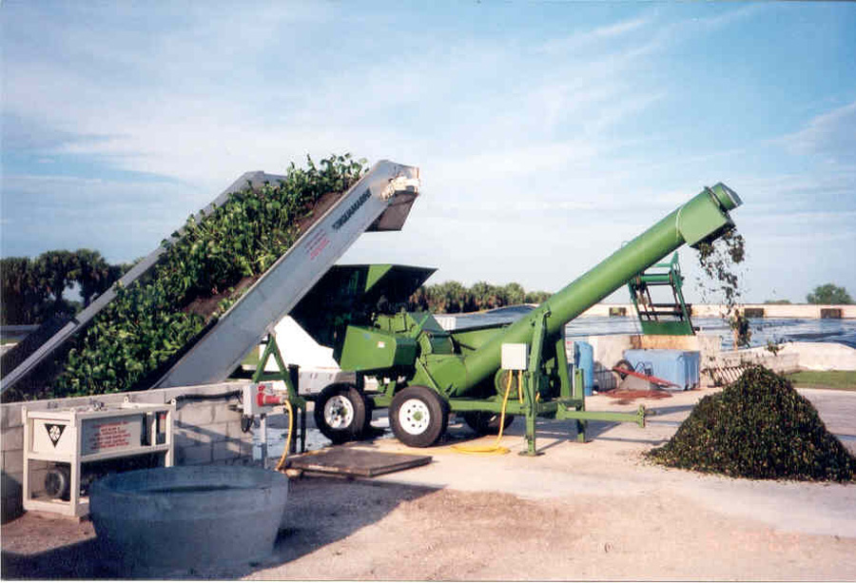

My efforts through the years related to water hyacinth cultivation have been oriented as a water treatment method targeting removal of nutrients and other pollutants. Initially these efforts were intended to secure a position in the market created by the Clean Water Act (CWA), through which wastewater treatment facilities were to be upgraded to include nutrient removal. Federal funding made this a viable market. However, in the early eighties the CWA implementation deviated from nutrient reduction and from federal participation in capital funding. Water pollution control essentially became an unfunded mandate—which meant degradation of the market.

However recent changes in interpretation of the CWA, as a result of lawsuits by Earthjustice and others has led to increased efforts to restore the quality of select surface waters—a program called Total Maximum Daily Load or TMDL. This has opened up new markets for MAPS systems, including hyacinths and other technologies such as the Algal Turf Scrubber® or ATS™. Shown in the page following this text is a picture collage of an ATS™ which was designed by HydroMentia to help satisfy TMDL requirements. This facility is presently in operation in Indian River County, Florida.

The primary problem with marketing MAPS solely as a water treatment method to accommodate the new TMDL directives is the complete dependence upon the enforcement and implementation of the regulations. This market is capricious to say the least, and the client is typically some type of governmental agency. As you can imagine there is a resistance to developing the infrastructure to accommodate the TMDL requirements, as it is expensive, at least in the minds of those upon whom the regulations are imposed. Therefore implementation is slow, typically being delayed by legal efforts to either circumvent the regulatory demands, or somehow dilute the requirements. I have found this is a flimsy foundation upon which to build an innovative new company.

Therefore, it seems reasonable to build upon not only the water treatment capabilities, but also upon value of products. If a program were to be successful it would have to include both markets, with the goal to ensure product sales capable of fully supporting costs without the treatment component.

At the present time in Florida, the Water Management Districts are seeking programs which can remove large quantities of phosphorus and nitrogen from impaired waters. The St. Johns River Water Management District (SJRWMD) is presently involved with the restoration of Lake Apopka in Central Florida (31,000 acres), while the South Florida Water Management District (SFWMD) is investigating means of restoring Lake Okeechobee (450,000 acres). HydoMentia has in the past worked closely with both. At this time SJRWMD appears to be willing to contract on a price per pound of phosphorus (or nitrogen) removed. Systems they have investigated to date have been chemical precipitation, dredging, and marsh floways. None of them include an emphasis upon recovery of these nutrients or the subsequent development of products, and the price per pound removal for phosphorus has been high—in the hundreds of dollars per pound. It will likely require the removal of over 2,000,000 pounds of phosphorus to facilitate some level of restoration in Lake Apopka. At $100/lb this amounts to $200,000,000. There would certainly be hesitation to invest such a sum, considering there is little guarantee of a meaningful short term restoration. However, at $30/pound of phosphorus removed, the costs would be reduced to $60,000,000, or about $6,000,000 per year over a ten year restoration. If a MAPS facility could be built that supplemented this fee with substantial product sales, then this could be a feasible strategy.

As noted earlier, one dry ton of hyacinths has a phosphorus removal value of about $210—7 pounds at $30/pound. So what is the product value? As bulk compost, one dry ton of hyacinths may be worth $35 to $50. If sold retail in bags this may increase to $100-200/ton, but of course processing costs would also increase. The value is higher for livestock feed, but to penetrate the market will take large available quantities, and extensive feeding trials. Hyacinths are already being used for fiber products as a cottage industry in under-developed countries where labor is inexpensive.[9] There is also a niche market for highly priced furniture made from water hyacinth fiber.[10] Some investigations have been made into the production of paper from water hyacinths as well.[11] A brief Google search can be done to gather substantial information regarding various uses of water hyacinths, but as of yet, a product which could handle the volumes of biomass needed to facilitate meaningful water reclamation even in Florida alone, has not been identified, nor have extensive investigations been conducted to this end.

Just to give an idea of the amount of biomass which might be involved with a Lake Apopka project, I ran our Hyacinth Design Model (HYADEM) for a system which could remove 216 tons of phosphorus per year. It would require 2,400 acres of cultivation area (ponds), and harvesting of 3,574,000 wet tons per year, resulting in a yield of 42,340 dry tons of raw product. Obviously we are looking at commodity levels, not niche markets. This does not mean niche markets could be accommodated by a portion of the crop, but it is imperative that a home be found for the bulk of the material. This could be as paper for bags or toilet paper, or parchment etc., or it could be a livestock feed ingredient, or as a carbon base for a fuel such as biogas, or a bulk organic soil amendment. The selection of products or combination of products is a challenge we need to confront.

And of course, integration with other crops would need to be considered. Once the MAPS have improved the quality of the water, it could be used for irrigation for select terrestrial crops, or for fish/shellfish aquaculture.

A logical approach would be to establish a small full scale demonstration project—preferably one which results in some return for nutrient removal services. The project would be situated next to or near impaired surface water, such as Lake Apopka or Lake Okeechobee. During the design and permitting process, literature and industry searches would be conducted regarding viable products and product markets. In addition, fees would be negotiated with the involved agency(ies). The results of the searches will be used in establishing product research and development efforts at the facility.

In general R&D efforts would be targeted towards resolution of the following issues

* Cultivation Unit Design
* Confirmation of Projected Crop Production and Quality
* Documenting Water Quality Improvement
* Optimization of Harvest and Transport Systems
* Optimization of Initial Processing Systems
* Identification of Process Requirements
* Market Investigations
* Sales and Promotion Strategy
* Community and Agency Relationships
* Economic Review and *Pro Forma* / Business Plan Development
* Identify Funding Sources for Second Tier Expansion

I think this serves as a starting point for our discussions Saturday. Each of you brings valuable experiences and talents to the table. I look forward to active and production discussions.

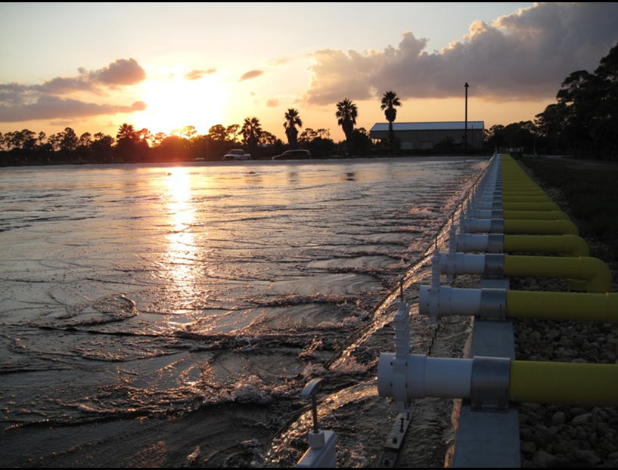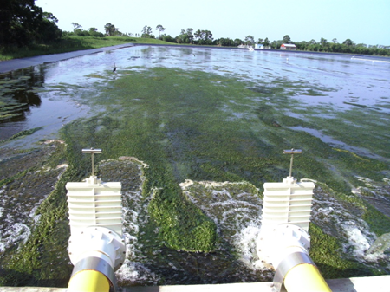

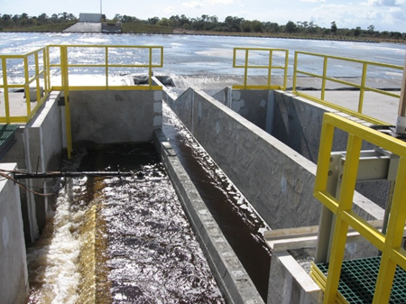

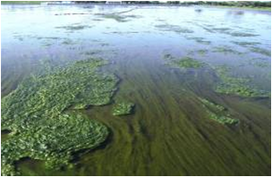

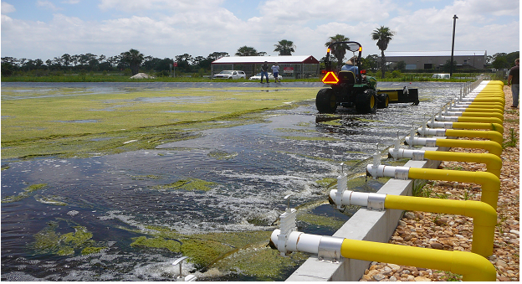

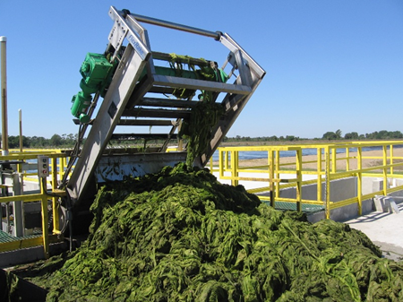

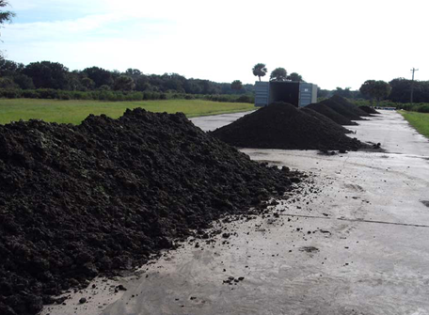

|  |  |
| --- | --- |
|  |  |

|  |  |
| --- | --- |
| **HYADEM APOPKA PROJECTED FULL SCALE FACILITY 9/14** |  |
| INPUTS |  |
| Influent Average Daily Flow (mgd) | 1,200 |
| Days between harvests | 7 |
| Average Total Nitrogen Concentration (mg/l) | 4.63 |
| Daily Nitrogen Supplementation lb | 0.00 |
| Influent Total Nitrogen (mg/l) | 5.00 |
| Influent Total Nitrogen including Supplementation mg/l | 5.00 |
| Influent Total Phosphorus (mg/l) | 0.180 |
| Influent Total Phosphorus (ppb) | 180 |
| V'ant Hoff Arrhenius Coefficient | 1.07 |
| Average Air Temperature (degrees C) | 25.00 |
| Maximium Specific Growth Rate (1/day) | 0.048 |
| Wet Crop Density (lb/sf) | 3.50 |
| Density Adjustment Factor | 1.00 |
| Half Rate Concentration (mg/l TN) | 5.00 |
| Incidental Nitrogen Loss Cn | 0.10 |
| Growing Area (acres) | 2,400 |
| Percent Coverage | 85.00% |
| Plant Nitrogen Content (% dry weight) | 2.30% |
| Plant Phosphorus Content (% dry weight) | 0.40% |
| Percent Solids Harvest | 6.50% |
| In-Pond and sloughed Plant percent solids | 5.00% |
| OUTPUTS |  |
| Standing Crop (Wet Tons) | 155,509 |
| Field Water Hyacinth Growth Rate (1/day) | 0.019 |
| Sloughing Rate (1/day) | 0.004 |
| Net Specific Growth Rate (1/day) | 0.015 |
| Average Pond Depth (ft) | 4.00 |
| Hydraulic retention time (days) | 2.61 |
| Hydraulic Loading Rate (cm/day) | 46.77 |
| Mean Plant Age days | 53.11 |
| Average Daily Growth (Wet Tons) | 2,956 |
| Average Daily Growth (Dry Tons) | 148 |
| Average Daily Harvest (Wet Tons) | 1,787 |
| Average Daily Harvest (Dry Tons) | 116 |
| Average Daily Sloughing (Wet Tons) | 623 |
| Average Daily Sloughing (Dry Tons) | 31 |
| **WHS™ Effluent Total Nitrogen (mg/l)** | **4.25** |
| **WHS™ Effluent Total Phosphorus (mg/l)** | **0.062** |
| **WHS™ Effluent Total Phosphorus (ppb)** | **62** |
| Nitrogen Removal lb/day | 3,395 |
| Nitrogen Removal ton/yr | 620 |
| Nitrogen Removal Rate lb/acre-day | 3.12 |
| Nitrogen Removal Rate g/sm-yr | 128 |
| Phosphorus Removal lb/day | 1,182 |
| Phosphorus Removal ton/yr | 216 |
| Phosphorus Removal Rate lb/acre-day | 0.49 |
| Phosphorus Removal Rate g/sm-yr | 20.16 |
|  |  |
| Annual Service Fee @ $30/pound phosphorus Removed | $12,945,712 |

1. <http://vlib.iue.it/carrie/reference/worldhistory/sections/18civili.html>
2. H.T. Odum 1971 *Environment Power and Society* Wiley-Interscience , New York, NY USA pg 149
3. *IBID* pg 182
4. *IBID* pg 60 *“In man’s study of himself he has often made his systems study with the economic consideration of currency only, thus omitting much of his system. Little wonder that his understanding and predictions of his economy have been faulty.”*
5. e.g. Gilding, Paul 2011 *The Great Disruption* Bloomsbury Press, New York, NY USA
6. Stumm, W and E. Stumm-Zollinger 1971 Chemostasis and Homeostasis in Aquatic Ecosystems; Principles of Water Pollution Control In Nonequilibrium Systems in Natural Water Chemistry; Hem, J.; Advances in Chemistry; American Chemical Society: Washington, DC
7. There is an irony here, for those today who politically call themselves conservatives often tout the continuation of fossil fuel consumption without a strategy for transitioning to other energy sources. I believe most political conservatives would agree that they are resistant to sizable deviations from the status-quo—cautious traditionalists. This traditional consumption scientifically however is anything but conservative, for it implies low stability and rapid system changes. Hence todays conservatives are in reality radicals, rebelling against necessary adjustments to conserve our socio-economic system.
8. Please understand I am not suggesting this system is optimal, it is what is available to date.
9. [www.mekong-creations.org/products/water-hyaicnth.html](http://www.mekong-creations.org/products/water-hyaicnth.html)
10. <https://www.centuryfurniture.com/sustainability.aspx?show=whhttps://www.centuryfurniture.com/sustainability.aspx?show=wh>
11. <http://philjournalsci.dost.gov.ph/vol141no2/parchment%20like%20paper%20using%20water%20hyacinth%20pulp.htmlhttp://philjournalsci.dost.gov.ph/vol141no2/parchment%20like%20paper%20using%20water%20hyacinth%20pulp.html>